Physical Data Model

🌟 Definition
# Source: AI Source: Provided by: [Data Path: Persons Table -> ID Column: 1, Name_En Column: Motasem Essam] -> From: [ChatGPT] on [6/10/2026]
A Physical Data Model is the most detailed level of data modeling.
It describes how the database is actually implemented and stored in a specific DBMS such as:
- MySQL
- PostgreSQL
- Microsoft SQL Server
- Oracle Database
The Physical Model includes storage and performance details that are not present in the Conceptual or Logical models.

🎯 Purpose
# Source: AI Source: Provided by: [Data Path: Persons Table -> ID Column: 1, Name_En Column: Motasem Essam] -> From: [ChatGPT] on [6/10/2026]
The Physical Data Model is used to:
- Create actual database tables
- Define data types
- Define indexes
- Define constraints
- Optimize performance
- Configure storage structures

🧠 Key Question
# Source: AI Source: Provided by: [Data Path: Persons Table -> ID Column: 1, Name_En Column: Motasem Essam] -> From: [ChatGPT] on [6/10/2026]
A Physical Model answers:
How will the database actually store and manage the data?

🔄 From Conceptual to Physical
# Source: AI Source: Provided by: [Data Path: Persons Table -> ID Column: 1, Name_En Column: Motasem Essam] -> From: [ChatGPT] on [6/10/2026]
Conceptual Model
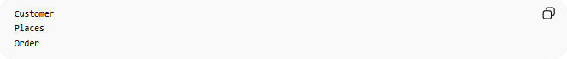
Customer
Places
Order
Business view only.

Logical Model
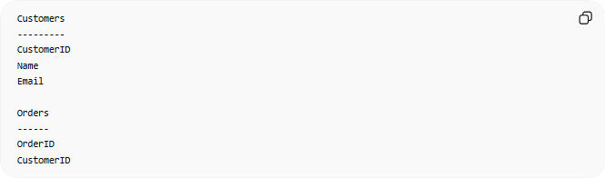
Customers
---------
CustomerID
Name
Email
Orders
------
OrderID
CustomerID
Structure view.

Physical Model
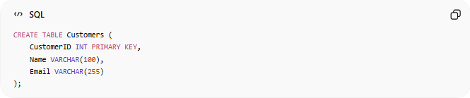
CREATE TABLE Customers (
CustomerID INT PRIMARY KEY,
Name VARCHAR(100),
Email VARCHAR(255)
);
Actual implementation.

📚 Online Store Example
# Source: AI Source: Provided by: [Data Path: Persons Table -> ID Column: 1, Name_En Column: Motasem Essam] -> From: [ChatGPT] on [6/10/2026]
Physical Customers Table
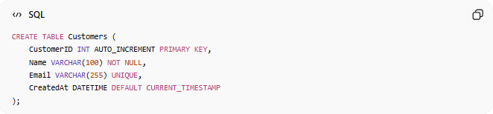
CREATE TABLE Customers (
CustomerID INT AUTO_INCREMENT PRIMARY KEY,
Name VARCHAR(100) NOT NULL,
Email VARCHAR(255) UNIQUE,
CreatedAt DATETIME DEFAULT CURRENT_TIMESTAMP
);

Physical Orders Table
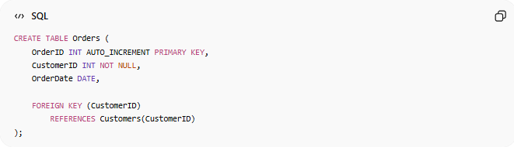
CREATE TABLE Orders (
OrderID INT AUTO_INCREMENT PRIMARY KEY,
CustomerID INT NOT NULL,
OrderDate DATE,
FOREIGN KEY (CustomerID)
REFERENCES Customers(CustomerID)
);

🧩 Main Components
# Source: AI Source: Provided by: [Data Path: Persons Table -> ID Column: 1, Name_En Column: Motasem Essam] -> From: [ChatGPT] on [6/10/2026]
1. Tables
Logical entities become physical tables.
Example:

Customers
Orders
Products

2. Columns
Logical attributes become physical columns.
Example:

CustomerID
Name
Email

3. Data Types
Physical models specify exact data types.
Examples:
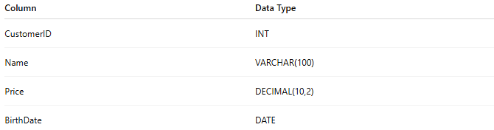
Column | Data Type
CustomerID | INT
Name | VARCHAR(100)
Price | DECIMAL(10,2)
BirthDate | DATE

4. Constraints
Physical implementation includes constraints.
Examples:

PRIMARY KEY
FOREIGN KEY
NOT NULL
UNIQUE
CHECK
DEFAULT

5. Indexes
Indexes improve query performance.
Example:

CREATE INDEX idx_email
ON Customers(Email);

6. Storage Details
The Physical Model may define:
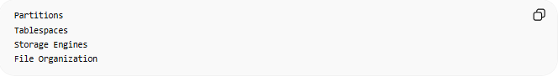
Partitions
Tablespaces
Storage Engines
File Organization

📊 Example Physical ER Structure
# Source: AI Source: Provided by: [Data Path: Persons Table -> ID Column: 1, Name_En Column: Motasem Essam] -> From: [ChatGPT] on [6/10/2026]
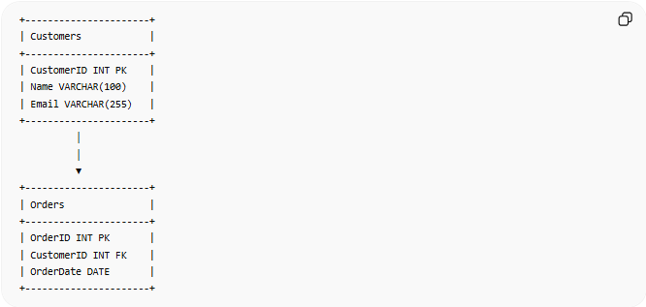
+----------------------+
| Customers |
+----------------------+
| CustomerID INT PK |
| Name VARCHAR(100) |
| Email VARCHAR(255) |
+----------------------+
│
│
▼
+----------------------+
| Orders |
+----------------------+
| OrderID INT PK |
| CustomerID INT FK |
| OrderDate DATE |
+----------------------+

🔢 Characteristics of a Physical Model
# Source: AI Source: Provided by: [Data Path: Persons Table -> ID Column: 1, Name_En Column: Motasem Essam] -> From: [ChatGPT] on [6/10/2026]
A Physical Model:
- DBMS-specific
- Highly detailed
- Includes storage information
- Includes performance optimization
- Ready for deployment

🌍 University Example
# Source: AI Source: Provided by: [Data Path: Persons Table -> ID Column: 1, Name_En Column: Motasem Essam] -> From: [ChatGPT] on [6/10/2026]
Students Table

CREATE TABLE Students (
StudentID INT PRIMARY KEY,
Name VARCHAR(100) NOT NULL,
Email VARCHAR(255) UNIQUE
);

Courses Table

CREATE TABLE Courses (
CourseID INT PRIMARY KEY,
Title VARCHAR(100)
);

Enrollment Table

CREATE TABLE Enrollment (
StudentID INT,
CourseID INT,
PRIMARY KEY (StudentID, CourseID),
FOREIGN KEY (StudentID)
REFERENCES Students(StudentID),
FOREIGN KEY (CourseID)
REFERENCES Courses(CourseID)
);

🚀 Performance Features
# Source: AI Source: Provided by: [Data Path: Persons Table -> ID Column: 1, Name_En Column: Motasem Essam] -> From: [ChatGPT] on [6/10/2026]
Physical models often include optimization features.
Indexes

CREATE INDEX idx_student_email
ON Students(Email);

Partitions
Example:

Orders_2024
Orders_2025
Orders_2026
Large tables can be divided into smaller parts.

Storage Engines
Example in MySQL:
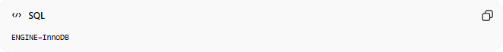
ENGINE=InnoDB

🔄 Conceptual vs Logical vs Physical
# Source: AI Source: Provided by: [Data Path: Persons Table -> ID Column: 1, Name_En Column: Motasem Essam] -> From: [ChatGPT] on [6/10/2026]
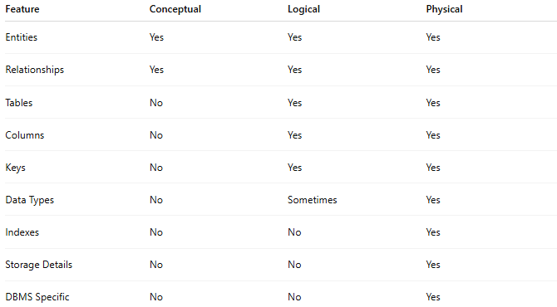
Feature | Conceptual | Logical | Physical
Entities | Yes | Yes | Yes
Relationships | Yes | Yes | Yes
Tables | No | Yes | Yes
Columns | No | Yes | Yes
Keys | No | Yes | Yes
Data Types | No | Sometimes | Yes
Indexes | No | No | Yes
Storage Details | No | No | Yes
DBMS Specific | No | No | Yes

📊 Example Progression
# Source: AI Source: Provided by: [Data Path: Persons Table -> ID Column: 1, Name_En Column: Motasem Essam] -> From: [ChatGPT] on [6/10/2026]
Conceptual

Customer
Places
Order

Logical
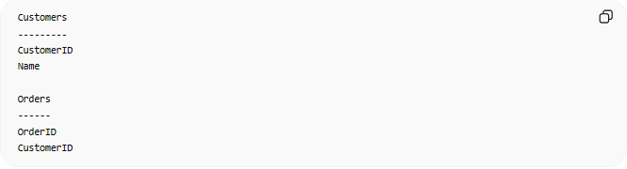
Customers
---------
CustomerID
Name
Orders
------
OrderID
CustomerID

Physical

CREATE TABLE Customers (
CustomerID INT AUTO_INCREMENT PRIMARY KEY,
Name VARCHAR(100) NOT NULL
);

🧠 Simple Analogy
# Source: AI Source: Provided by: [Data Path: Persons Table -> ID Column: 1, Name_En Column: Motasem Essam] -> From: [ChatGPT] on [6/10/2026]
Think of building a house.
Conceptual

Living Room
Kitchen
Bedroom
What rooms are needed?

Logical
Living Room = 6m × 5m
Kitchen = 4m × 4m
How is the house structured?

Physical
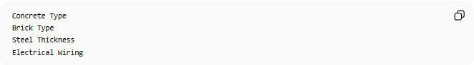
Concrete Type
Brick Type
Steel Thickness
Electrical Wiring
How is the house actually built?

🧭 Summary
# Source: AI Source: Provided by: [Data Path: Persons Table -> ID Column: 1, Name_En Column: Motasem Essam] -> From: [ChatGPT] on [6/10/2026]
A Physical Data Model is the actual implementation of a database in a specific DBMS. It defines tables, columns, data types, constraints, indexes, storage settings, and performance optimizations. It is the final stage of database design and is used to create and deploy a working database system.

